**КОРОНАВИРУС**

[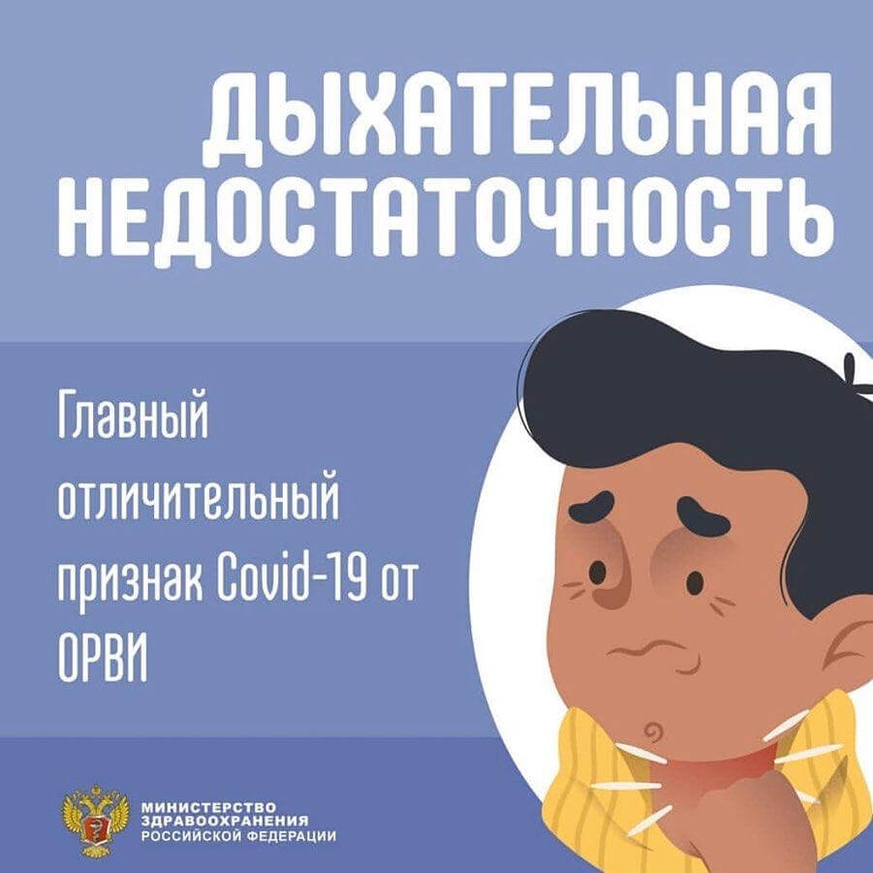](http://rodnichok-ds.ru/wp-content/uploads/2020/03/IMG-20200318-WA0003.jpg) [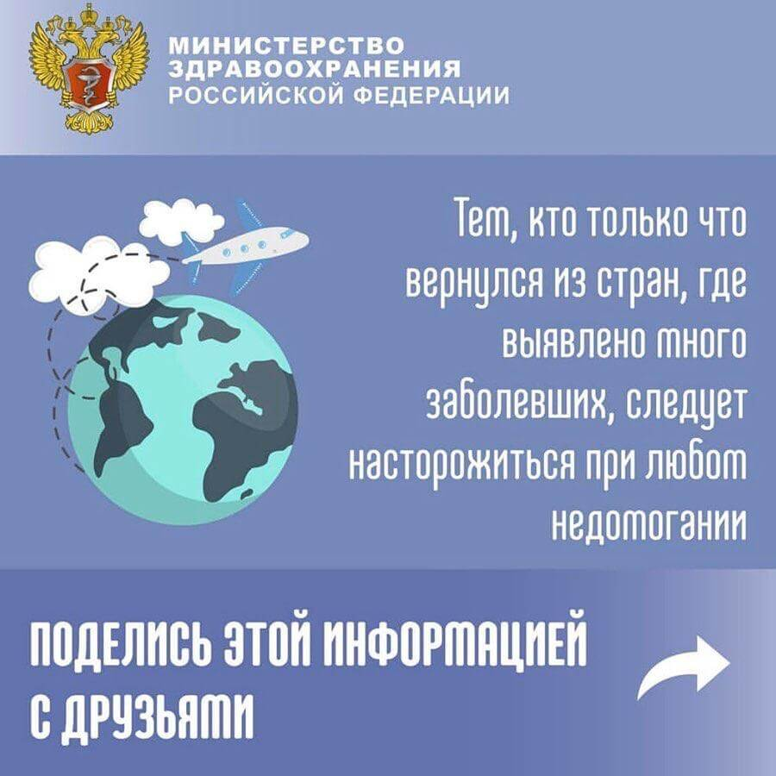](http://rodnichok-ds.ru/wp-content/uploads/2020/03/IMG-20200318-WA0004.jpg)

[](http://rodnichok-ds.ru/wp-content/uploads/2020/03/IMG-20200318-WA0005.jpg) [](http://rodnichok-ds.ru/wp-content/uploads/2020/03/IMG-20200318-WA0006.jpg)

[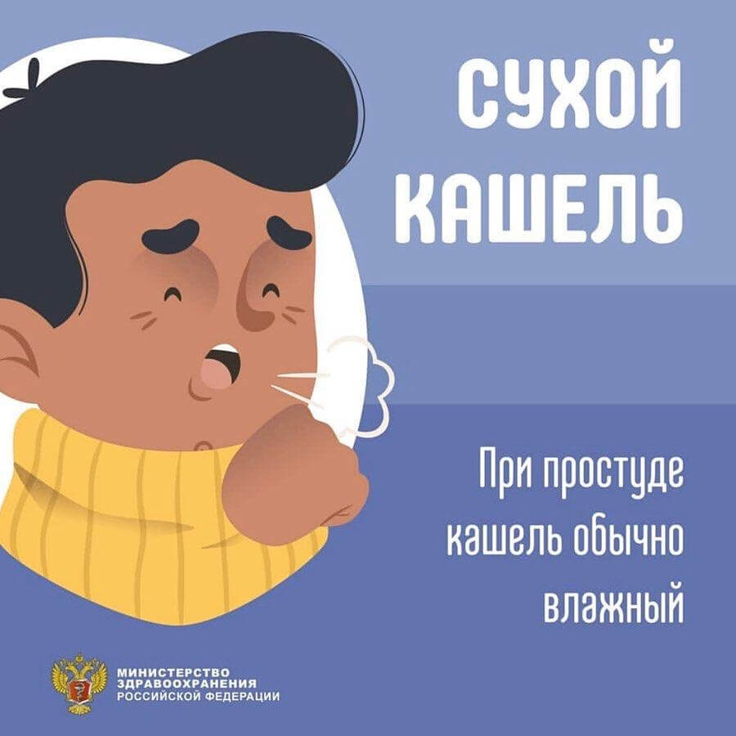](http://rodnichok-ds.ru/wp-content/uploads/2020/03/IMG-20200318-WA0007.jpg) [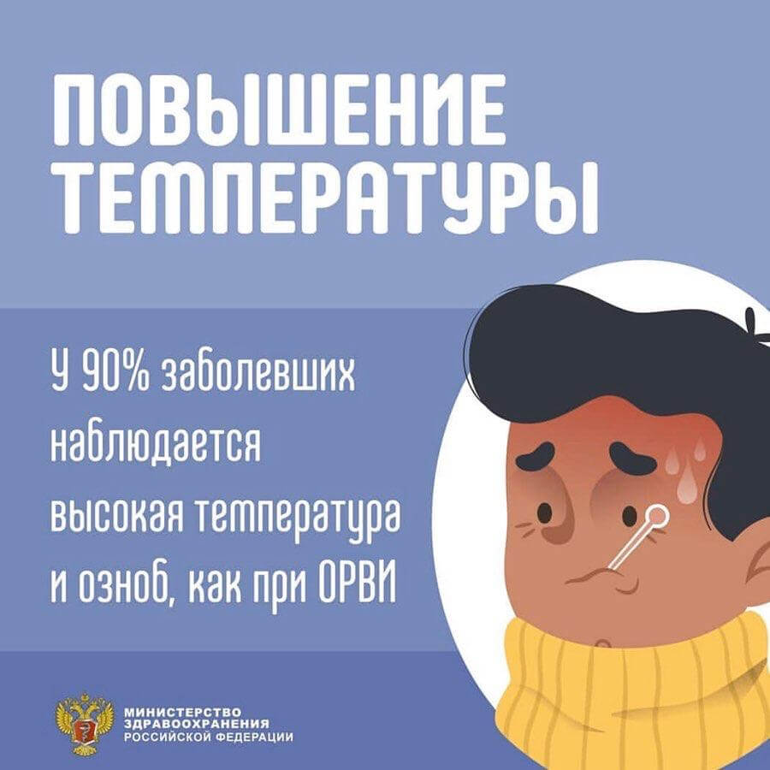](http://rodnichok-ds.ru/wp-content/uploads/2020/03/IMG-20200318-WA0008.jpg)

[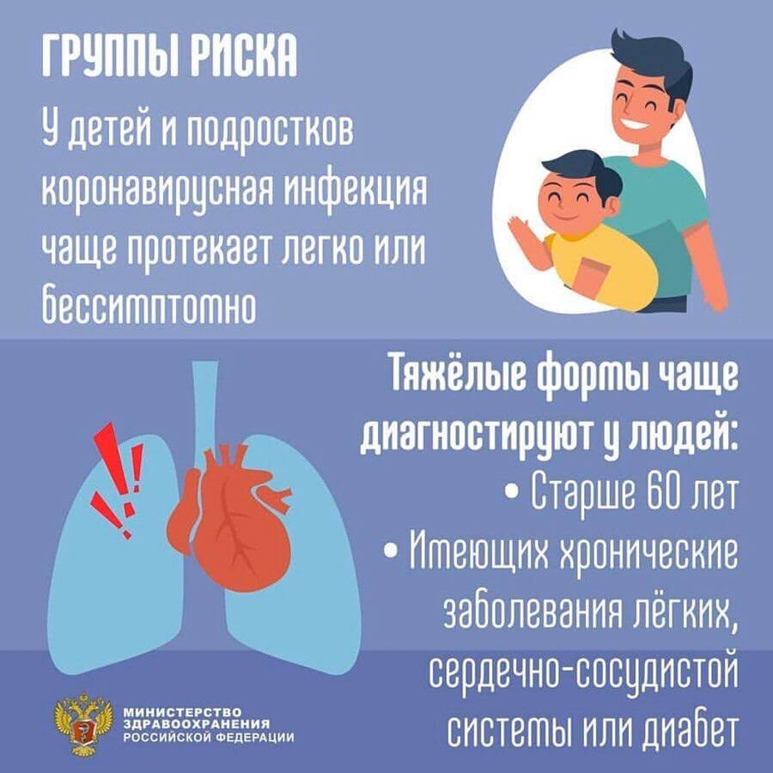](http://rodnichok-ds.ru/wp-content/uploads/2020/03/IMG-20200318-WA0009.jpg)